ELaNa # ODAR

CougSat-1 – WSU Cougs in Space – 1U CubeSat

**Stowed**

Solar cells (line item 19)

Structure (1)

Antenna form (23)

GPS antenna (15)

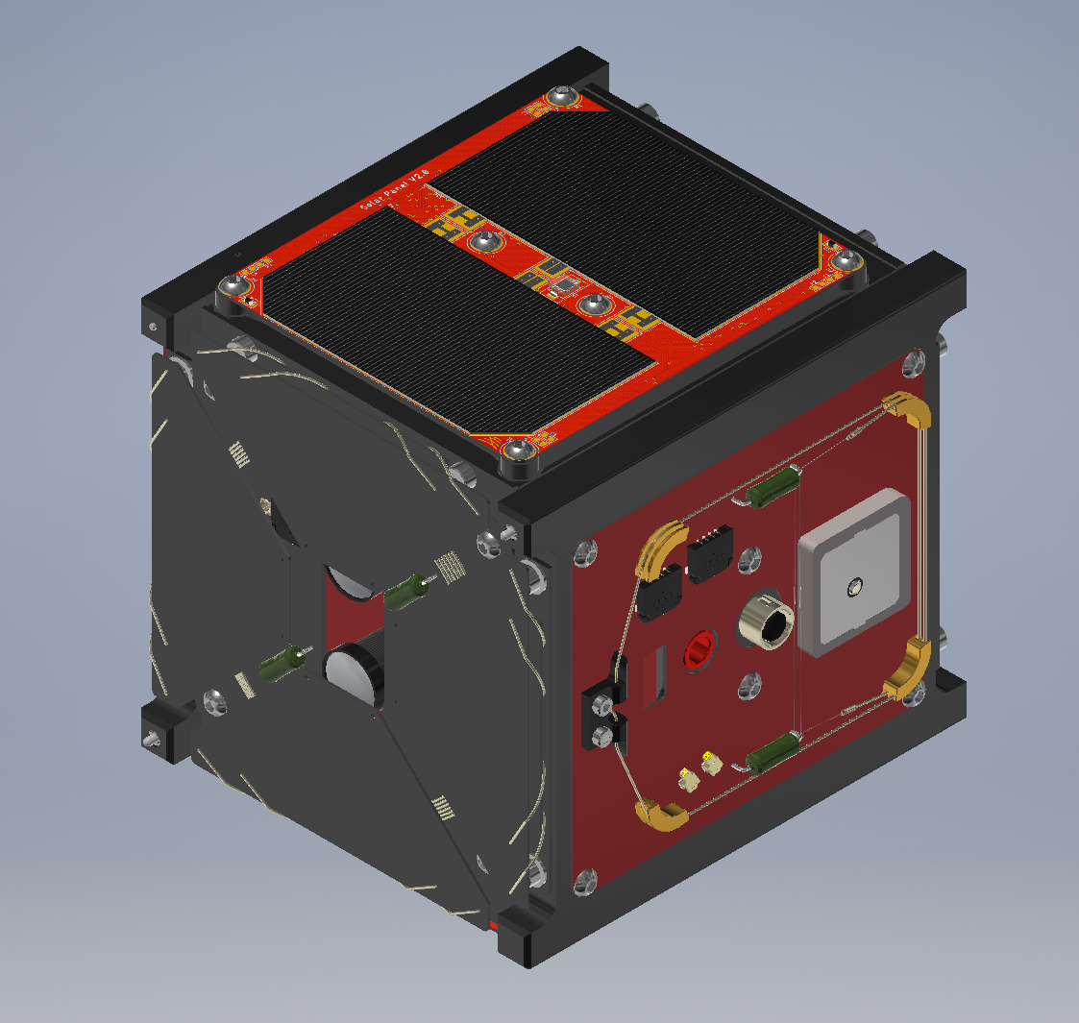

**Deployed**

Antenna 1 (17)

Camera lens (14)

Antenna 2 (18)

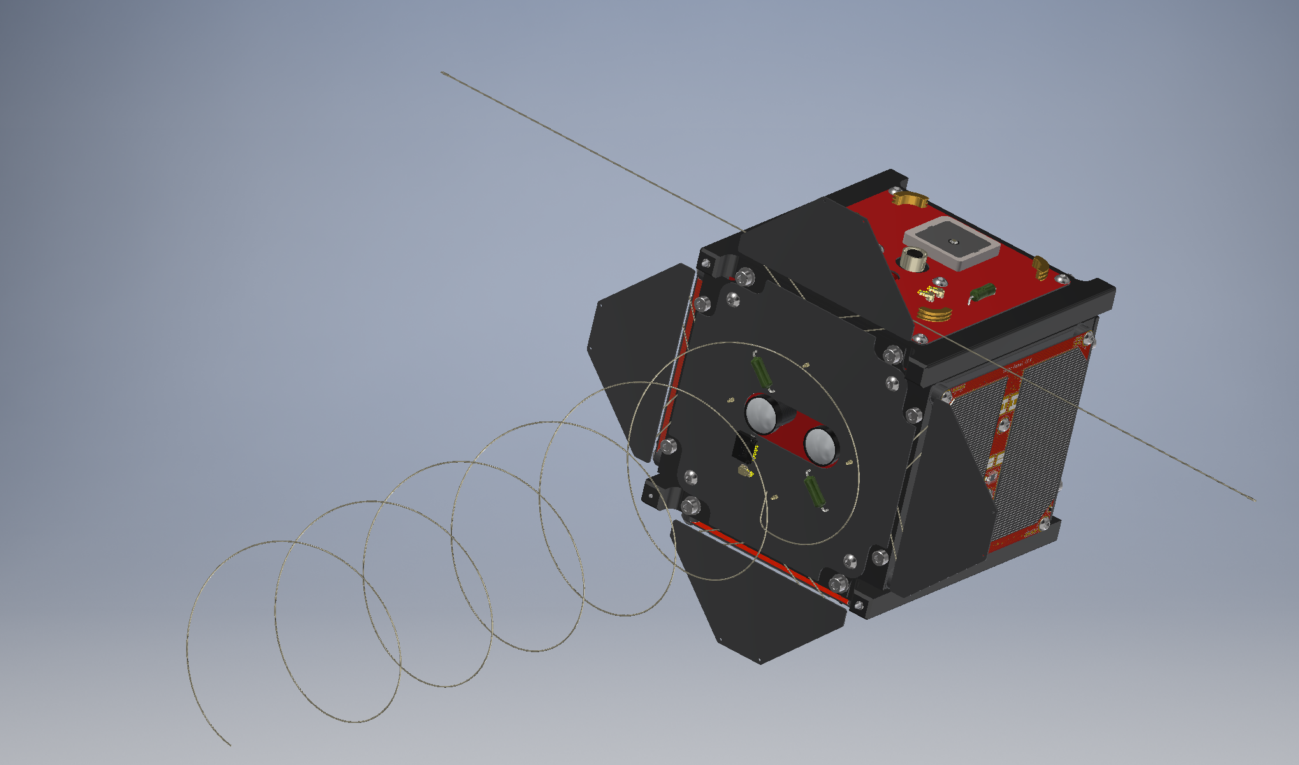

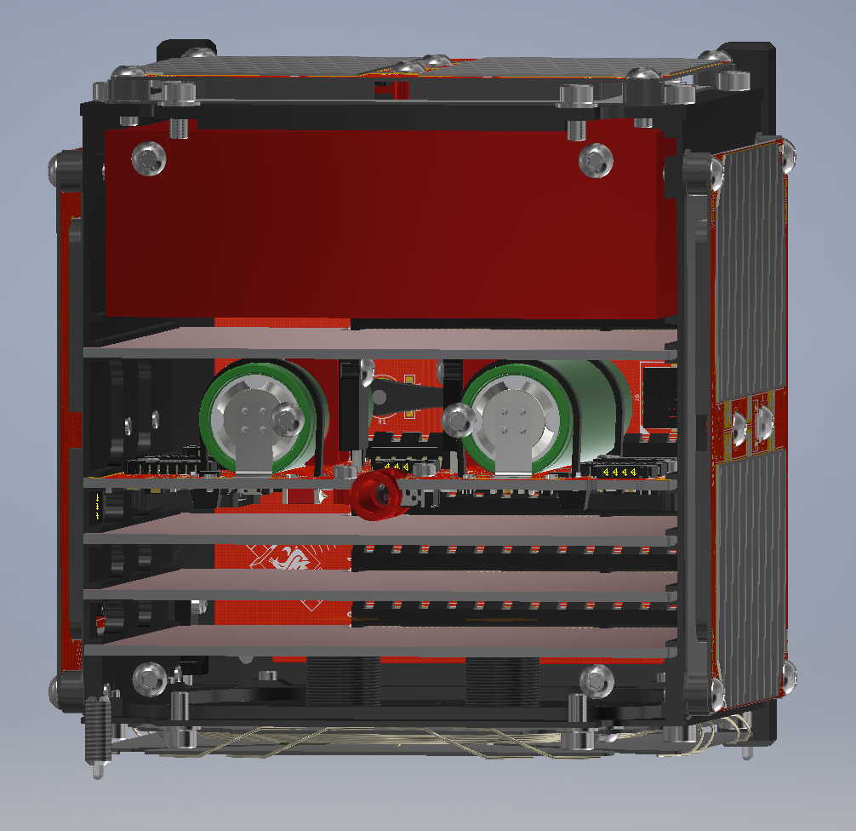

**Cross section**

Magnetorquer (22)

Germination chamber (20, 21)

Batteries (16)

**Brief Overview:** CougSat-1 is a 1U satellite primarily constructed to path find Washington State University’s satellite club. The official missions are as follows:

1. Develop a reliable and robust bus for nanosatellites
2. Be capable of reprogramming the satellite
3. Put a WSU cougar head into orbit
4. Test an experiment apparatus studying plant germination in microgravity

**CONOPS:** Upon release from the deployment tube, CougSat-1 begins counting its timers. At T+30minutes, CougSat-1 will release its deployables: two antennas. No debris should be ejected in this process. At T+45minutes, the UHF beacon begins transmitting. Then normal operations begins, the satellite alternates between siting idle/charging its batteries, taking pictures of earth, and transmitting data down to Ground. Around T+3days, CougSat-1 will begin supporting the germination experiment payload. This involves stabilizing the plants’ temperature, taking photos of them, and measuring CO2 levels. Upon the conclusion of the experiment, 30days after starting, the plants remain in their chamber and die.

**Materials:** The structure is made of Al6061-T6 with steel bolts. It contains all commercial off the shelf electrical components. The GPS patch antenna is made of ceramic. There are three small camera lenses made of glass. There are solar cells that have a layer of cover glass.

**Hazards:** There are no hazardous or exotic materials. There is a pressure chamber of 1atm.

**Batteries:** The EPS is built in-house with Panasonic NCR18650B which are listed under UL MH12210. They are charged with Spectrolab UTJ solar cells. The EPS has independent cell protection for over-charge, over-discharge, over-voltage, under-voltage, and short circuit faults.